Lab 05 - Implement Intersite Connectivity

#### Task 1: Provision the lab environment

In this task three virtual machines are deployed, each into a separate virtual network, with two of them in the same Azure region and the third one in another Azure region.

The two required files are uploaded then Resource group is created and the first two virtual networks and a pair of virtual machines are deployed in East US region. The third virtual network and the third virtual machine are deployed in the same resource group but another region-West US. This is made in PowerShell:

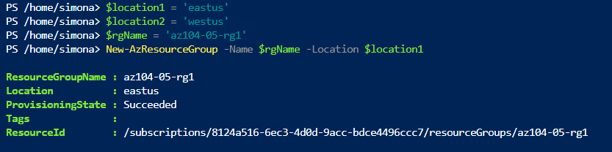

To create the three virtual networks and deploy virtual machines into them by using the uploaded template and parameter files the following commands are used:

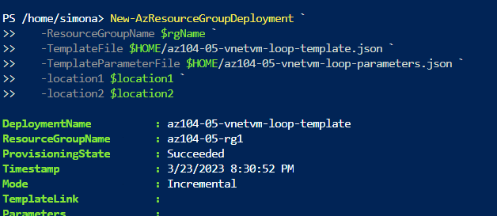

#### Task 2: Configure local and global virtual network peering

If we go to Virtual networks we can see the virtual networks created in the previous task and verify that the first two are located in the same Azure region and the third one in a different Azure region:

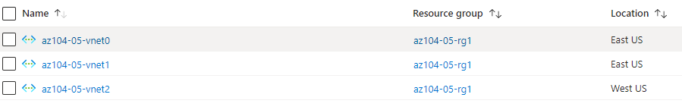

Next step is to configure local and global peering between the virtual networks. I have configured peering with the following commands:

$rgName = 'az104-05-rg1'

$vnet0 = Get-AzVirtualNetwork -Name 'az104-05-vnet0' -ResourceGroupName $rgname

$vnet1 = Get-AzVirtualNetwork -Name 'az104-05-vnet1' -ResourceGroupName $rgname

Add-AzVirtualNetworkPeering -Name 'az104-05-vnet0_to_az104-05-vnet1' -VirtualNetwork $vnet0 -RemoteVirtualNetworkId $vnet1.Id

Add-AzVirtualNetworkPeering -Name 'az104-05-vnet1_to_az104-05-vnet0' -VirtualNetwork $vnet1 -RemoteVirtualNetworkId $vnet0.Id

This step establishes two local peerings - one from az104-05-vnet0 to az104-05-vnet1 and the other from az104-05-vnet1 to az104-05-vnet0

Another peering is made- one from az104-05-vnet0 to az104-05-vnet2 and the other from az104-05-vnet2 to az104-05-vnet0.

And the last peering is one from az104-05-vnet1 to az104-05-vnet2 and the other from az104-05-vnet2 to az104-05-vnet1:

$rgName = 'az104-05-rg1'

$vnet1 = Get-AzVirtualNetwork -Name 'az104-05-vnet1' -ResourceGroupName $rgname

$vnet2 = Get-AzVirtualNetwork -Name 'az104-05-vnet2' -ResourceGroupName $rgname

Add-AzVirtualNetworkPeering -Name 'az104-05-vnet1_to_az104-05-vnet2' -VirtualNetwork $vnet1 -RemoteVirtualNetworkId $vnet2.Id

Add-AzVirtualNetworkPeering -Name 'az104-05-vnet2_to_az104-05-vnet1' -VirtualNetwork $vnet2 -RemoteVirtualNetworkId $vnet1.Id

#### Task 3: Test intersite connectivity

In this task we connect via Remote Desktop. Within the Remote Desktop session to **az104-05-vm0 in PowerShell** the following command is run to test connectivity to **az104-05-vm1** (which has the private IP address of **10.51.0.4**) over TCP port 3389:

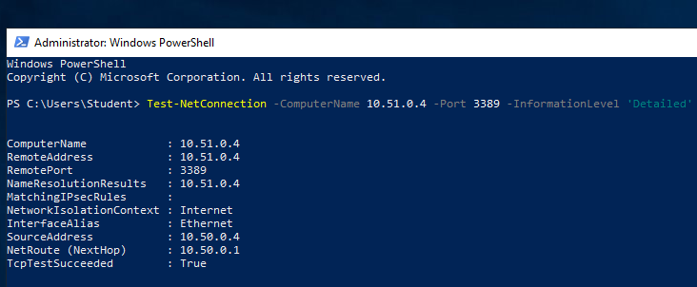

Also connectivity to **az104-05-vm2 is tested like previous.**